package Cau2;

public class Hinh {

public Hinh() {

}

public double dienTich() {

return dienTich();

}

@Override

public String toString() {

return "Hinh{" + '}';

}

}

package Cau2;

import java.util.Scanner;

public class HinhTron extends Hinh {

private float r;

public HinhTron() {

}

public HinhTron(float r) {

this.r = r;

}

public float getR() {

return r;

}

public void setR(float r) {

this.r = r;

}

@Override

public String toString() {

return "HinhTron{" + "r=" + r + '}';

}

public void nhapthongtin(){

Scanner sc = new Scanner(System.in);

System.out.print("Nhap vao ban kinh: ");

r = sc.nextFloat();

HinhTron ht = new HinhTron(r);

}

@Override

public double dienTich(){

return r\*r\*Math.PI;

}

}

package Cau2;

import java.util.Scanner;

public class HinhChuNhat extends Hinh {

private float cd;

private float cr;

public HinhChuNhat() {

}

public HinhChuNhat(float cd, float cr) {

this.cd = cd;

this.cr = cr;

}

public float getCd() {

return cd;

}

public void setCd(float cd) {

this.cd = cd;

}

public float getCr() {

return cr;

}

public void setCr(float cr) {

this.cr = cr;

}

@Override

public String toString() {

return "HinhChuNhat{" + "cd=" + cd + ", cr=" + cr + '}';

}

public void nhapthongtin() {

Scanner sc = new Scanner(System.in);

System.out.print("Nhap vao chieu rong: ");

cr = sc.nextFloat();

System.out.print("Nhap vao chieu dai: ");

cd = sc.nextFloat();

HinhChuNhat hcn = new HinhChuNhat(cd, cr);

}

@Override

public double dienTich() {

return this.cr \* this.cd;

}

}

package Cau2;

import java.util.ArrayList;

import java.util.List;

import java.util.Scanner;

public class DanhSachHinh {

Scanner sc = new Scanner(System.in);

ArrayList<Hinh> danhSachHinh = new ArrayList<>();

public DanhSachHinh() {

super();

}

public void nhap(int n) {

for (int i = 0; i < n; i++) {

System.out.println("Nhap 1 vao hinh tron");

System.out.println("Nhap 2 vao hinh chu nhat");

System.out.println("Nhap khac thoat");

System.out.print("Nhap: ");

int menu = sc.nextInt();

switch (menu) {

case 1:

HinhTron ht = new HinhTron();

ht.nhapthongtin();

danhSachHinh.add(ht);

System.out.println("da them thanh cong");

break;

case 2:

HinhChuNhat hcn = new HinhChuNhat();

hcn.nhapthongtin();

danhSachHinh.add(hcn);

System.out.println("them thanh cong");

default:

break;

}

}

}

public void xuat() {

for (Hinh danhsach : danhSachHinh) {

System.out.println(danhsach.toString());

System.out.println(danhsach.dienTich());

}

}

}

package Cau2;

public class Test {

public static void main(String[] args) {

DanhSachHinh danh = new DanhSachHinh();

danh.nhap(2);

danh.xuat();

}

}

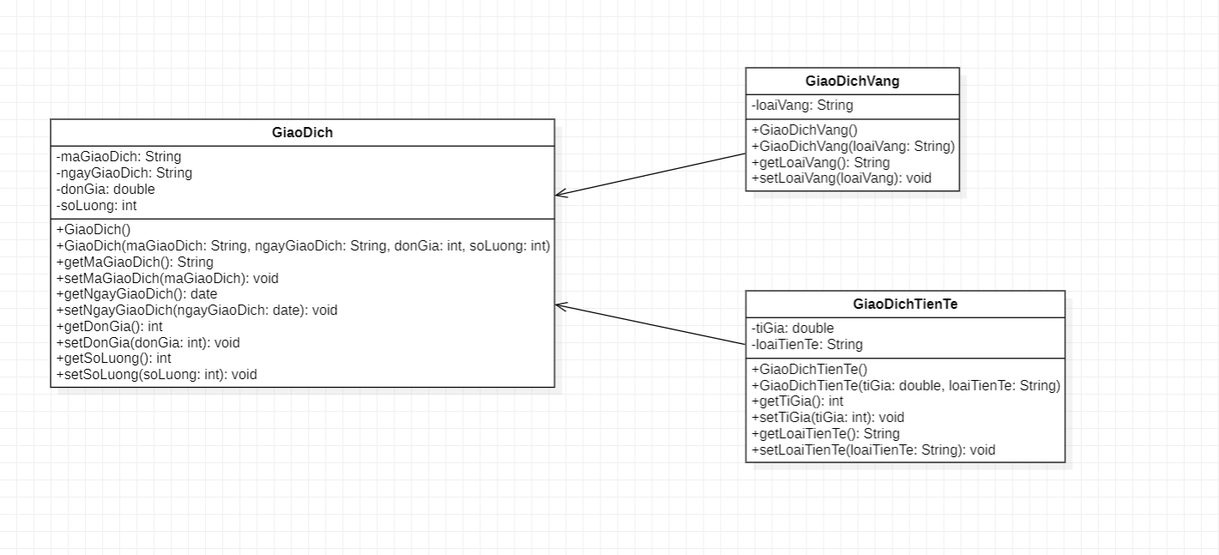

bài 3:

package Cau3;

public class GiaoDich {

private String ngayGiaoDich,maGiaoDich;

private int soLuong;

private double donGia;

public GiaoDich() {

}

public GiaoDich(String ngayGiaoDich, String maGiaoDich, int soLuong, double donGia) {

this.ngayGiaoDich = ngayGiaoDich;

this.maGiaoDich = maGiaoDich;

this.soLuong = soLuong;

this.donGia = donGia;

}

public String getNgayGiaoDich() {

return ngayGiaoDich;

}

public void setNgayGiaoDich(String ngayGiaoDich) {

this.ngayGiaoDich = ngayGiaoDich;

}

public String getMaGiaoDich() {

return maGiaoDich;

}

public void setMaGiaoDich(String maGiaoDich) {

this.maGiaoDich = maGiaoDich;

}

public double getDonGia() {

return donGia;

}

public void setDonGia(double donGia) {

this.donGia = donGia;

}

public int getSoLuong() {

return soLuong;

}

public void setSoLuong(int soLuong) {

this.soLuong = soLuong;

}

public double thanhTien(){

return 0;

}

@Override

public String toString() {

return "GiaoDich{" + "ngayGiaoDich=" + ngayGiaoDich + ", maGiaoDich=" + maGiaoDich + ", donGia=" + donGia + ", soLuong=" + soLuong + '}';

}

}

package Cau3;

import java.util.Scanner;

public class GiaoDichVang extends GiaoDich {

private String loaiVang;

public GiaoDichVang() {

}

public GiaoDichVang(String loaiVang, String ngayGiaoDich, String maGiaoDich, int soLuong, double donGia) {

super(ngayGiaoDich, maGiaoDich, soLuong, donGia);

this.loaiVang = loaiVang;

}

public String getLoaiVang() {

return loaiVang;

}

public void setLoaiVang(String loaiVang) {

this.loaiVang = loaiVang;

}

@Override

public double thanhTien(){

Scanner sc = new Scanner(System.in);

return soLuong \* donGia;

}

@Override

public String toString() {

return "GiaoDichVang{" + "loaiVang=" + loaiVang + '}';

}

}

package Cau3;

public class GiaoDichTienTe extends GiaoDich {

private double tiGia;

private String tienTe;

public GiaoDichTienTe() {

}

public GiaoDichTienTe(double tiGia, String tienTe, String ngayGiaoDich, String maGiaoDich, int soLuong, double donGia) {

super(ngayGiaoDich, maGiaoDich, soLuong, donGia);

this.tiGia = tiGia;

this.tienTe = tienTe;

}

public double getTiGia() {

return tiGia;

}

public void setTiGia(double tiGia) {

this.tiGia = tiGia;

}

public String getTienTe() {

return tienTe;

}

public void setTienTe(String tienTe) {

this.tienTe = tienTe;

}

@Override

public double thanhTien(){

if(tienTe.equalsIgnoreCase("USA")||tienTe.equalsIgnoreCase("EURO")){

return soLuong \* donGia \*tiGia;

}

else if(tienTe.equalsIgnoreCase("VN")){

return soLuong\*donGia;

}

else

return 0.0;

}

@Override

public String toString() {

return "GiaoDichTienTe{" + "tiGia=" + tiGia + ", tienTe=" + tienTe + '}';

}

}

package Cau3;

import java.util.ArrayList;

import java.util.List;

public class Main {

public static void main(String[] args) {

ArrayList<GiaoDich> giaodich = new ArrayList<>();

GiaoDichVang gdv = new GiaoDichVang("nguyenkhoi", "4/5/2020", "GD1", 4, 50000000);

GiaoDichVang gdv1 = new GiaoDichVang("duc", "9/4/2023", "GD2", 6, 30000000);

GiaoDichTienTe gdtt = new GiaoDichTienTe(4, "USA", "25/11/2023", "GDTT3", 2,90000000);

GiaoDichTienTe gdtt1 = new GiaoDichTienTe(5, "VN", "2/6/2023", "GD5", 5, 1000000000);

giaodich.add(gdv);

giaodich.add(gdv1);

giaodich.add(gdtt);

giaodich.add(gdtt1);

double tongSoLuongVang = 0.0;

double tongSoLuongTienTe = 0.0;

for(GiaoDich gd:giaodich){

if(gd instanceof GiaoDichVang){

tongSoLuongVang += gd.getSoLuong();

}

else if(gd instanceof GiaoDichTienTe){

tongSoLuongTienTe += gd.getSoLuong();

}

}

System.out.println("tong vang: " + tongSoLuongVang);

System.out.println("tong tien te: " + tongSoLuongTienTe);

double tongThanhTienTe = 0.0;

int soGiaoDichTienTe=0;

for(GiaoDich gd:giaodich){

if(gd instanceof GiaoDichTienTe){

tongThanhTienTe += gd.thanhTien();

soGiaoDichTienTe++;

}

}

double tb = tongSoLuongTienTe/soGiaoDichTienTe;

System.out.println("trung binh: "+ tb);

for(GiaoDich gd:giaodich){

if(gd.setDonGia()>10000000){

System.out.println("ma giao dich: "+ gd.getMaGiaoDich());

}

}

}

}